Week – 3:

Program – 1:

Lab 1: Understanding ORM with a Retail Inventory System

Scenario:

You’re building an inventory management system for a retail store. The store wants to

track products, categories, and stock levels in a SQL Server database.

Objective:

Understand what ORM is and how EF Core helps bridge the gap between C# objects and

relational tables.

Steps:

1. What is ORM?

• Explain how ORM maps C# classes to database tables.

• Benefits: Productivity, maintainability, and abstraction from SQL.

2. EF Core vs EF Framework:

• EF Core is cross-platform, lightweight, and supports modern features like

LINQ, async queries, and compiled queries.

• EF Framework (EF6) is Windows-only and more mature but less flexible.

3. EF Core 8.0 Features:

• JSON column mapping.

• Improved performance with compiled models.

• Interceptors and better bulk operations.

4. Create a .NET Console App:

dotnet new console -n RetailInventory

cd RetailInventory

5. Install EF Core Packages:

dotnet add package Microsoft.EntityFrameworkCore.SqlServer

dotnet add package Microsoft.EntityFrameworkCore.Design.

Sol: Product.cs

namespace RetailInventory.Models;

public class Product

{

public int ProductId { get; set; }

public string Name { get; set; }

public int Stock { get; set; }

public int CategoryId { get; set; }

public Category Category { get; set; }

}

Category.cs

namespace RetailInventory.Models;

public class Category

{

public int CategoryId { get; set; }

public string Name { get; set; }

public ICollection<Product> Products { get; set; }

}

RetailContext.cs

using Microsoft.EntityFrameworkCore;

using RetailInventory.Models;

namespace RetailInventory;

public class RetailContext : DbContext

{

public DbSet<Product> Products { get; set; }

public DbSet<Category> Categories { get; set; }

protected override void OnConfiguring(DbContextOptionsBuilder optionsBuilder)

{

optionsBuilder.UseSqlServer(@"Server=DESKTOP-II01DDJ\SQLEXPRESS;Database=RetailInventoryDB;Trusted_Connection=True;TrustServerCertificate=True;");

}

}

Program.cs

using RetailInventory;

using RetailInventory.Models;

using Microsoft.EntityFrameworkCore;

using var context = new RetailContext();

context.Database.EnsureCreated(); // Auto-creates DB if not exists

// Seed data

if (!context.Categories.Any())

{

var electronics = new Category { Name = "Electronics" };

var grocery = new Category { Name = "Grocery" };

context.Categories.AddRange(electronics, grocery);

context.Products.AddRange(

new Product { Name = "Laptop", Stock = 10, Category = electronics },

new Product { Name = "Apples", Stock = 50, Category = grocery }

);

context.SaveChanges();

}

// Display data

var products = context.Products.Include(p => p.Category).ToList();

foreach (var p in products)

{

Console.WriteLine($"{p.Name} ({p.Category.Name}) - Stock: {p.Stock}");

}

Output: 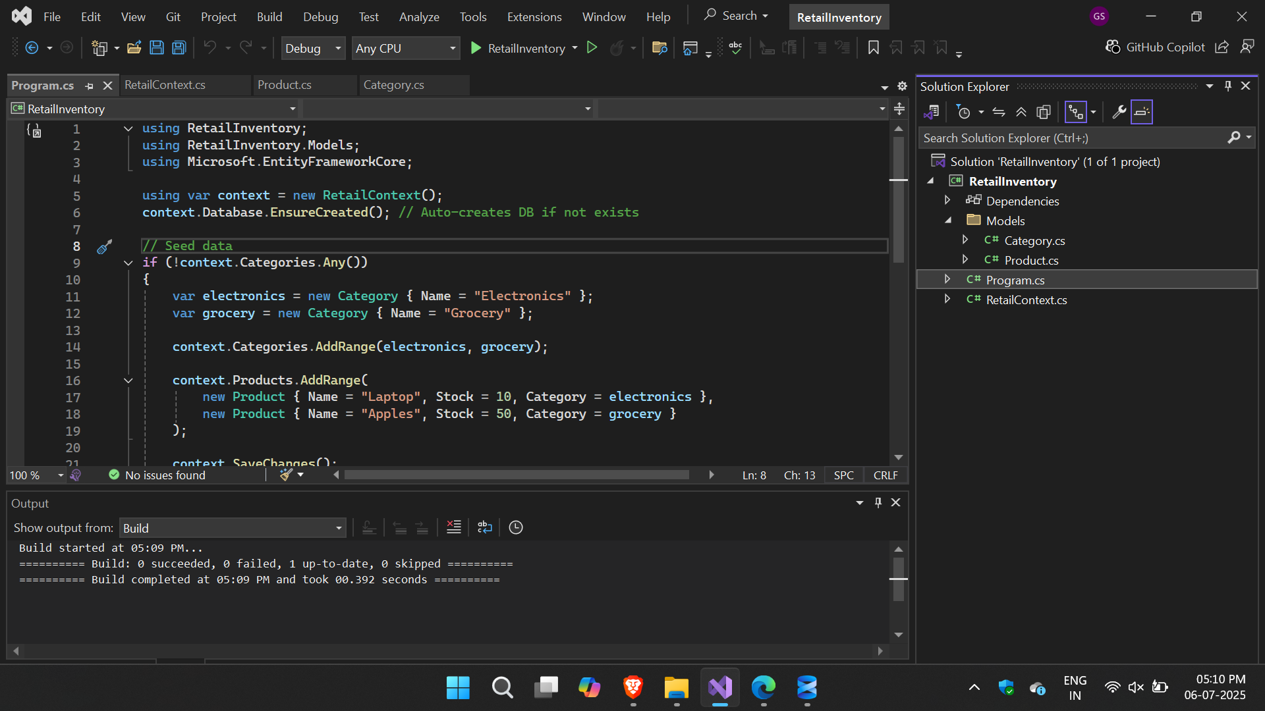

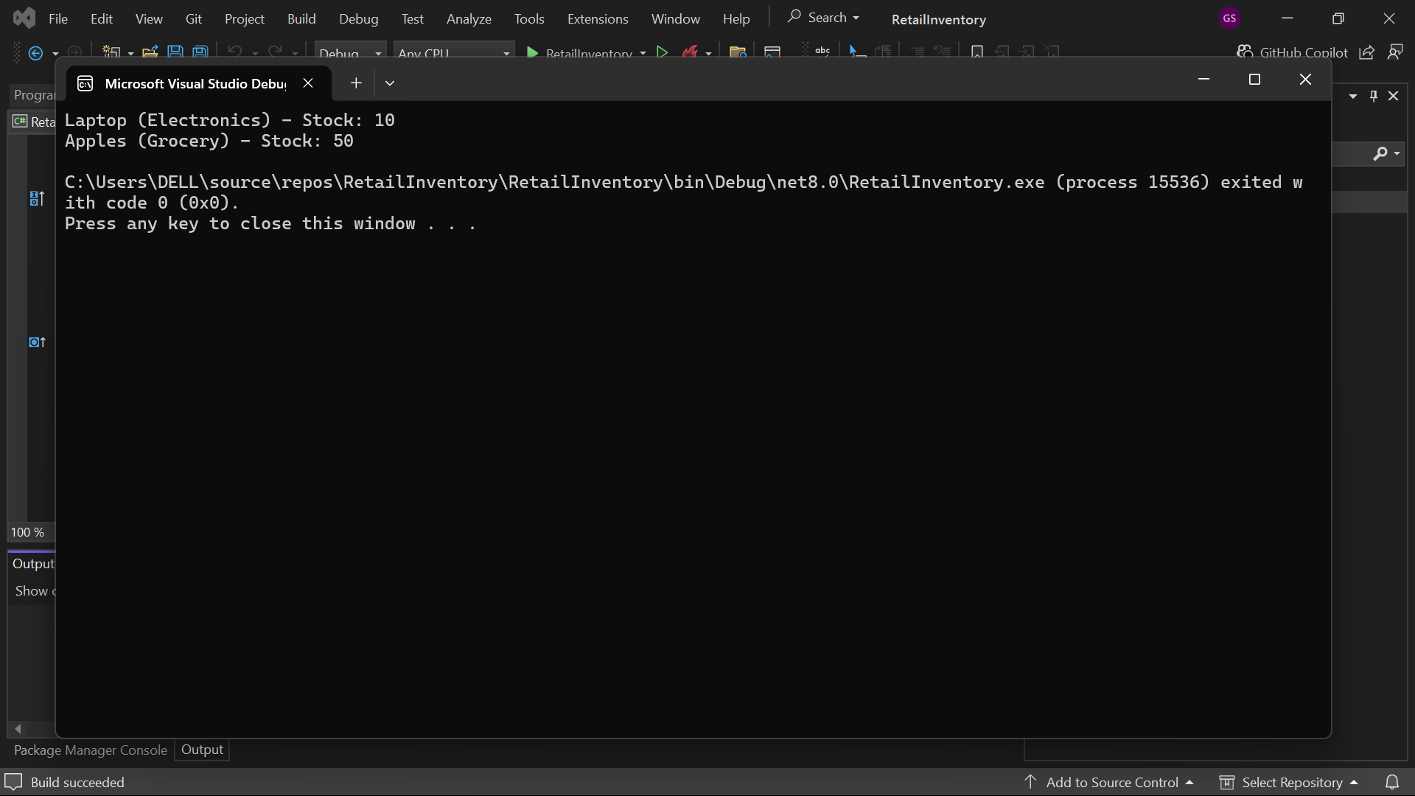

Program – 2:

Lab 2: Setting Up the Database Context for a Retail Store

Scenario:

The retail store wants to store product and category data in SQL Server.

Objective:

Configure DbContext and connect to SQL Server.

Steps:

1. Create Models:

public class Category {

public int Id { get; set; }

public string Name { get; set; }

public List Products { get; set; }

}

public class Product {

public int Id { get; set; }

public string Name { get; set; }

public decimal Price { get; set; }

public int CategoryId { get; set; }

public Category Category { get; set; }

}

2. Create AppDbContext:

public class AppDbContext : DbContext {

public DbSet Products { get; set; }

public DbSet Categories { get; set; }

protected override void OnConfiguring(DbContextOptionsBuilder optionsBuild

er) {

optionsBuilder.UseSqlServer("Your_Connection_String_Here");

}

}

Sol:

Products.cs

namespace RetailApp.Models;

public class Product

{

public int Id { get; set; }

public string Name { get; set; }

public decimal Price { get; set; }

public int CategoryId { get; set; }

public Category Category { get; set; }

}

Category.cs

namespace RetailApp.Models;

public class Category

{

public int Id { get; set; }

public string Name { get; set; }

public List<Product> Products { get; set; }

}

AppDbContext.cs

using Microsoft.EntityFrameworkCore;

using RetailApp.Models;

namespace RetailApp;

public class AppDbContext : DbContext

{

public DbSet<Product> Products { get; set; }

public DbSet<Category> Categories { get; set; }

protected override void OnConfiguring(DbContextOptionsBuilder optionsBuilder)

{

optionsBuilder.UseSqlServer(@"Server=DESKTOP-II01DDJ\SQLEXPRESS;Database=RetailStoreDB;Trusted_Connection=True;TrustServerCertificate=True;");

}

}

Program.cs

using Microsoft.EntityFrameworkCore;

using RetailApp;

using RetailApp.Models;

using var context = new AppDbContext();

context.Database.EnsureCreated();

if (!context.Categories.Any())

{

var electronics = new Category { Name = "Electronics" };

var grocery = new Category { Name = "Grocery" };

context.Categories.AddRange(electronics, grocery);

context.Products.AddRange(

new Product { Name = "TV", Price = 30000, Category = electronics },

new Product { Name = "Milk", Price = 40, Category = grocery }

);

context.SaveChanges();

}

foreach (var product in context.Products.Include(p => p.Category))

{

Console.WriteLine($"{product.Name} - ₹{product.Price} - Category: {product.Category.Name}");

}

Output:

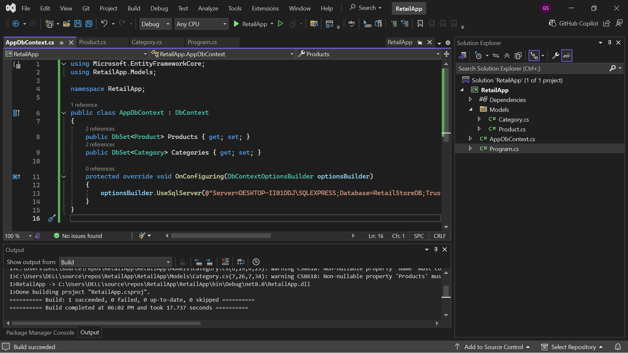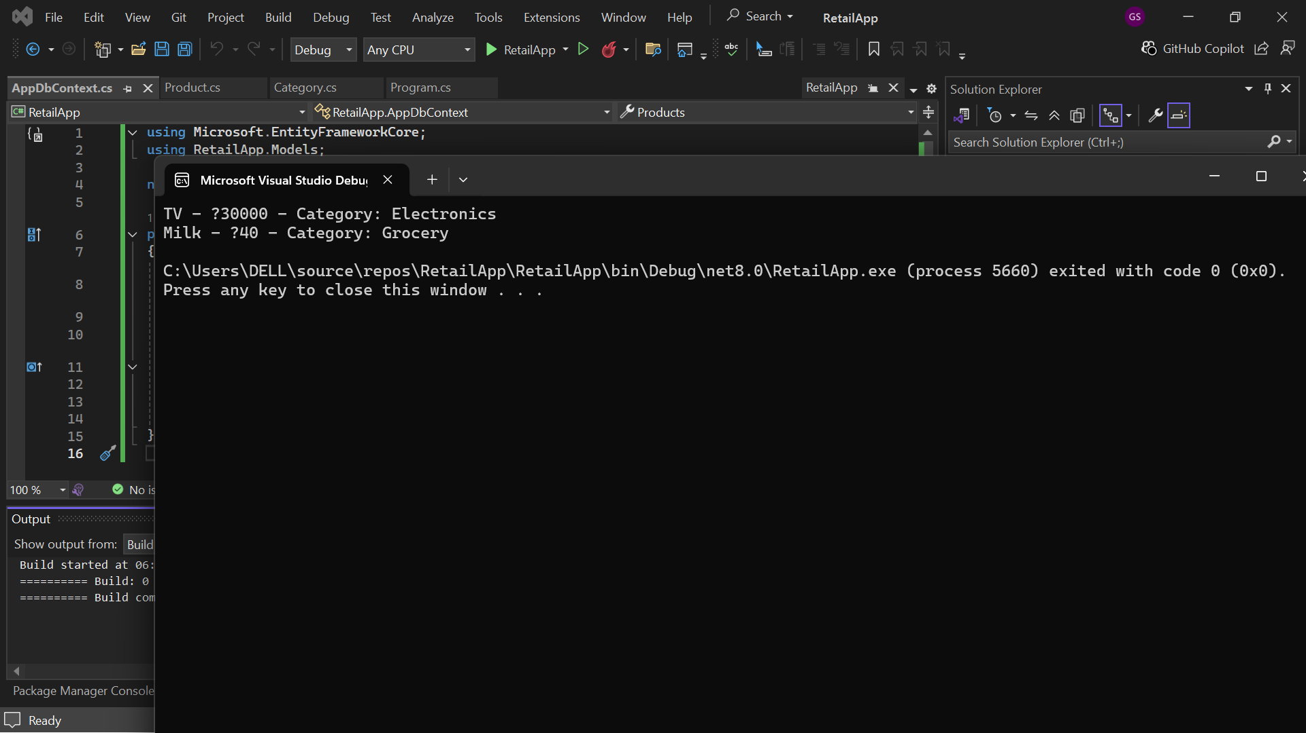

Program – 3:

Lab 3: Using EF Core CLI to Create and Apply Migrations

Scenario:

The retail store's database needs to be created based on the models you've defined.

You’ll use EF Core CLI to generate and apply migrations.

Objective:

Learn how to use EF Core CLI to manage database schema changes.

Steps:

1. Install EF Core CLI (if not already):

dotnet tool install --global dotnet-ef

2. Create Initial Migration:

dotnet ef migrations add InitialCreate

This generates a Migrations folder with code that represents the schema.

3. Apply Migration to Create Database:

dotnet ef database update

4. Verify in SQL Server:

Open SQL Server Management Studio (SSMS) or Azure Data Studio and confirm

that tables Products and Categories are created.

Sol: 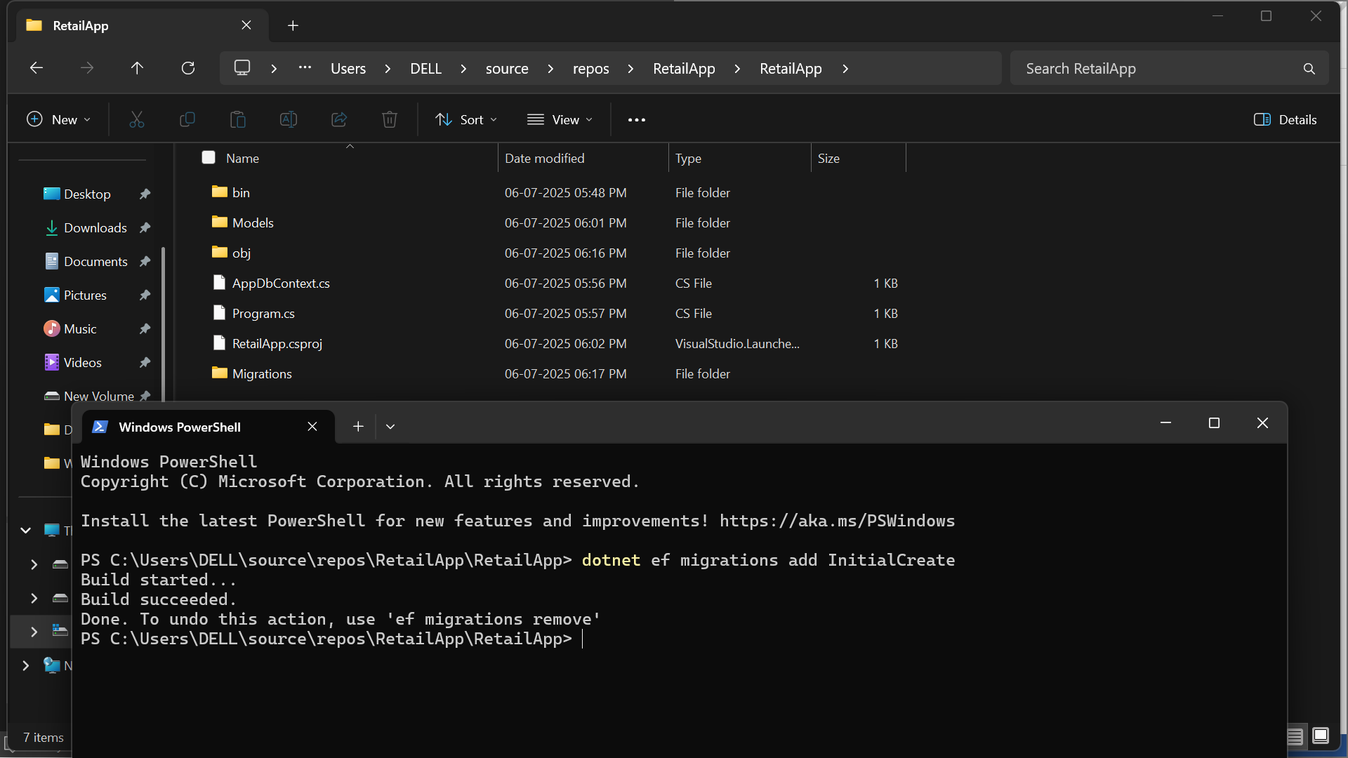

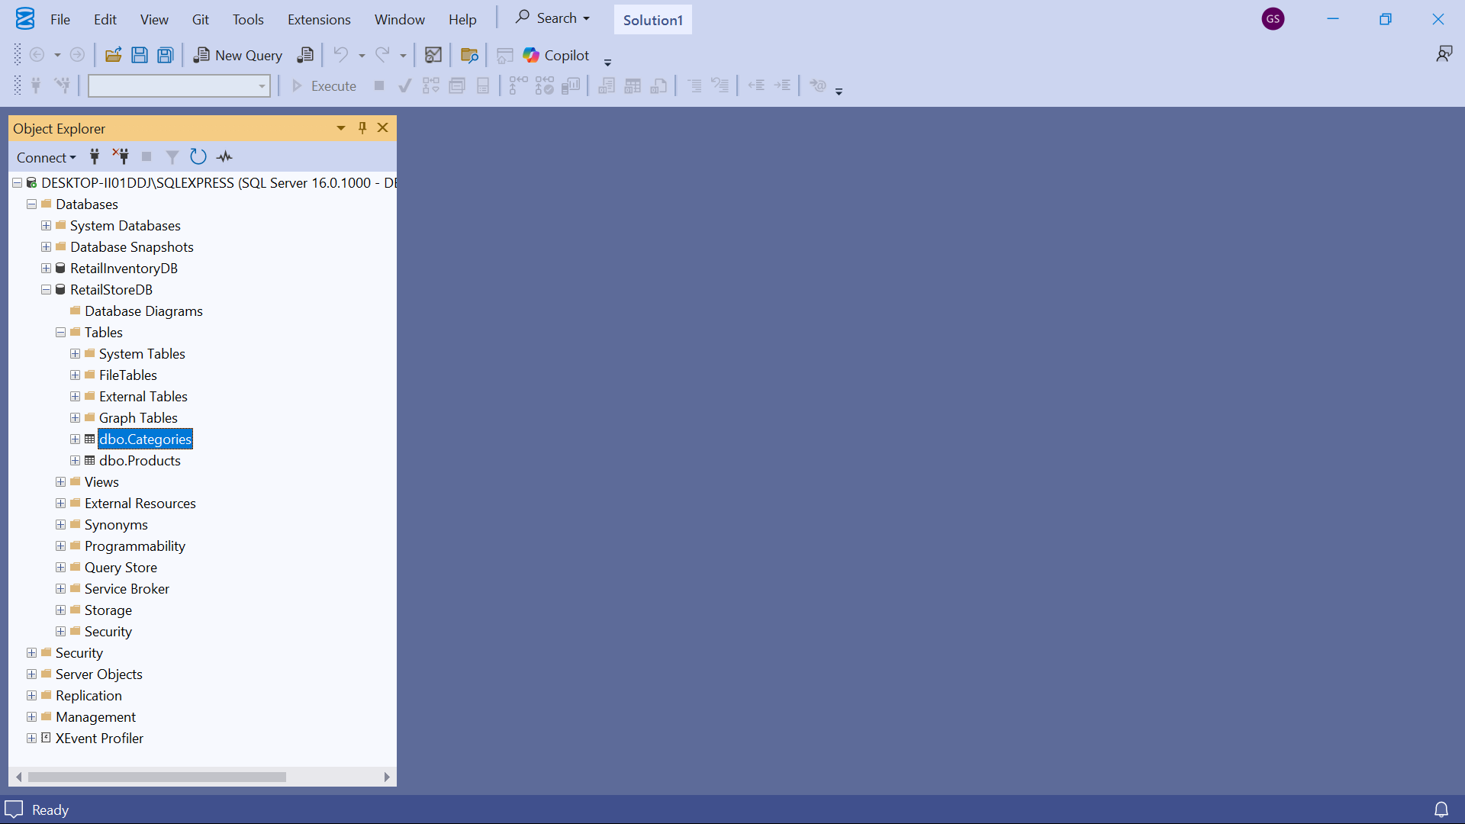

Program – 4:

Lab 4: Inserting Initial Data into the Database

Scenario:

The store manager wants to add initial product categories and products to the system.

Objective:

Use EF Core to insert records using AddAsync and SaveChangesAsync.

Steps:

1. Insert Data in Program.cs:

using var context = new AppDbContext();

var electronics = new Category { Name = "Electronics" };

var groceries = new Category { Name = "Groceries" };

await context.Categories.AddRangeAsync(electronics, groceries);

var product1 = new Product { Name = "Laptop", Price = 75000, Category = electro

nics };

var product2 = new Product { Name = "Rice Bag", Price = 1200, Category = groceri

es };

await context.Products.AddRangeAsync(product1, product2);

await context.SaveChangesAsync();

2. Run the App:

dotnet run

3. Verify in SQL Server:

Check that the data is inserted correctly.

Sol:

Program.cs

using RetailApp;

using RetailApp.Models;

using Microsoft.EntityFrameworkCore;

var context = new AppDbContext();

// Ensure DB is created (optional if migrations already applied)

await context.Database.EnsureCreatedAsync();

// Seed data only if DB is empty

if (!await context.Categories.AnyAsync())

{

var electronics = new Category { Name = "Electronics" };

var groceries = new Category { Name = "Groceries" };

await context.Categories.AddRangeAsync(electronics, groceries);

var product1 = new Product { Name = "Laptop", Price = 75000, Category = electronics };

var product2 = new Product { Name = "Rice Bag", Price = 1200, Category = groceries };

await context.Products.AddRangeAsync(product1, product2);

await context.SaveChangesAsync();

Console.WriteLine("Initial data inserted.");

}

else

{

Console.WriteLine("Data already exists.");

}

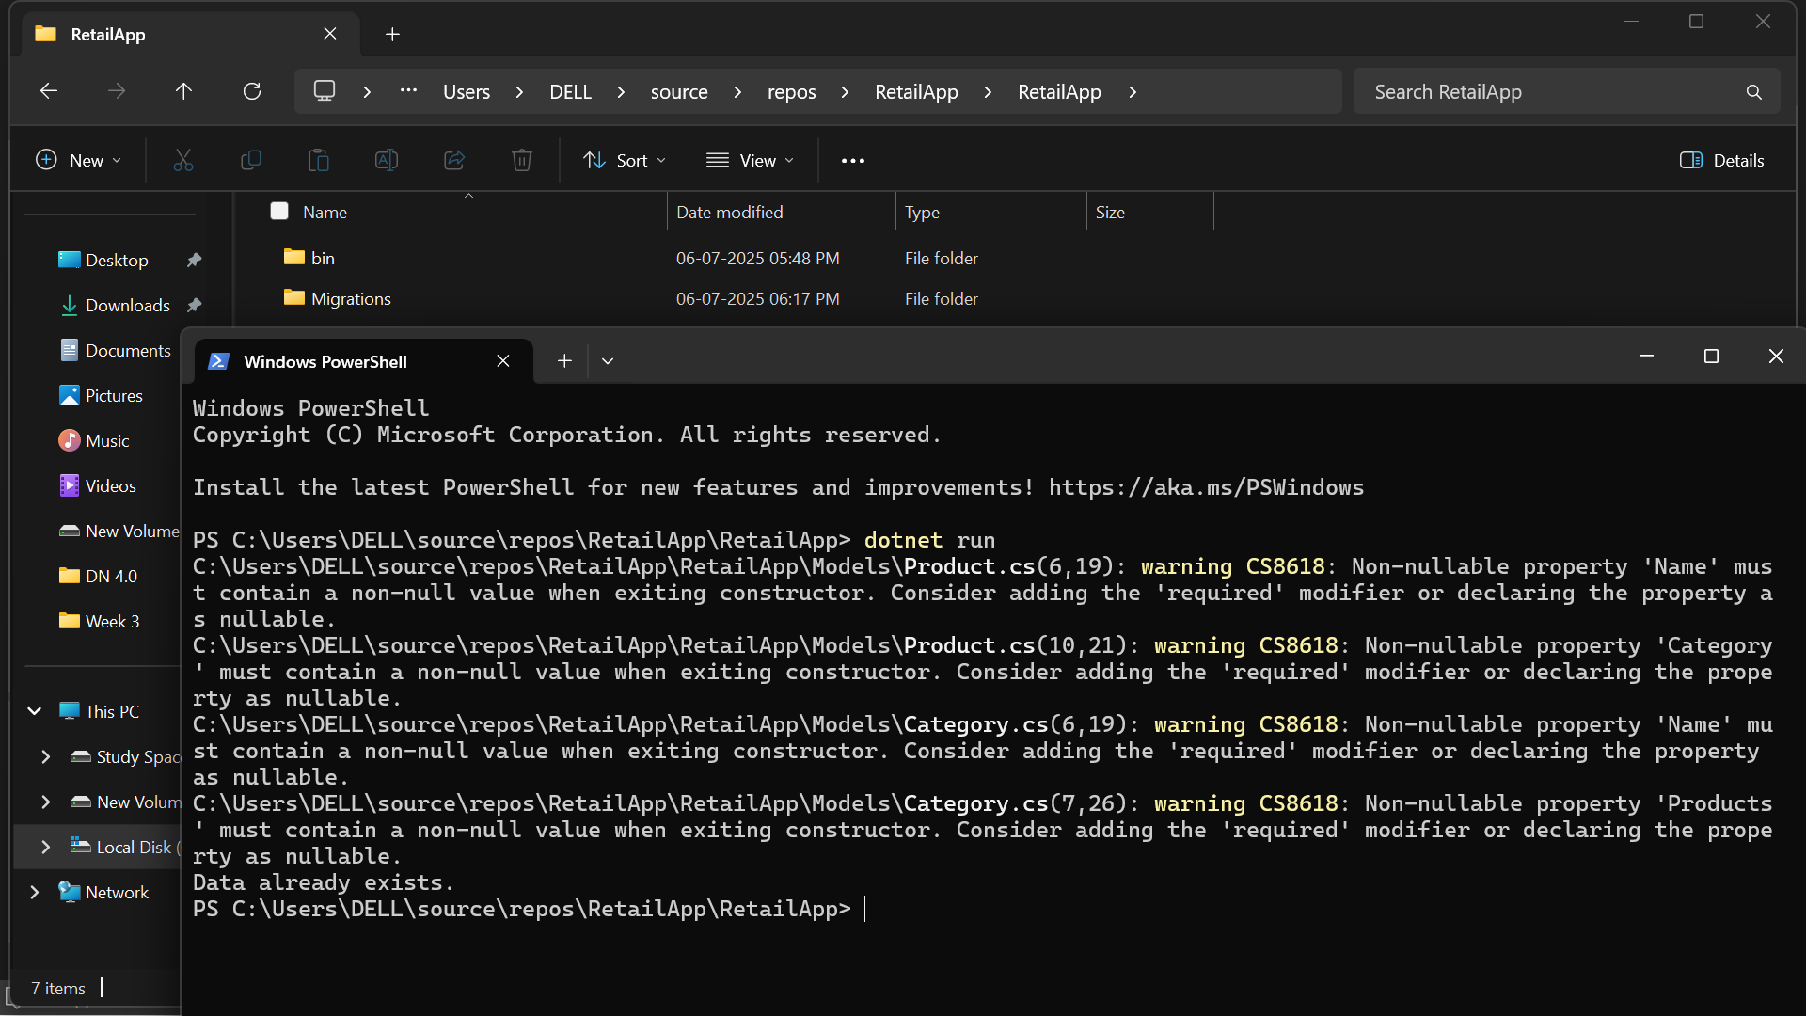

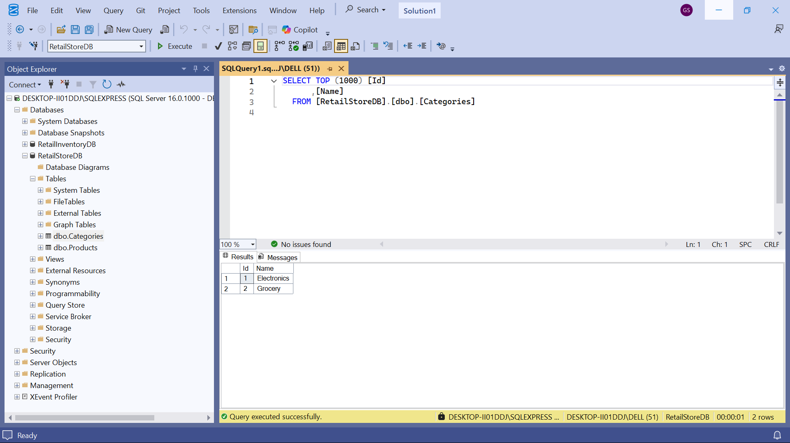

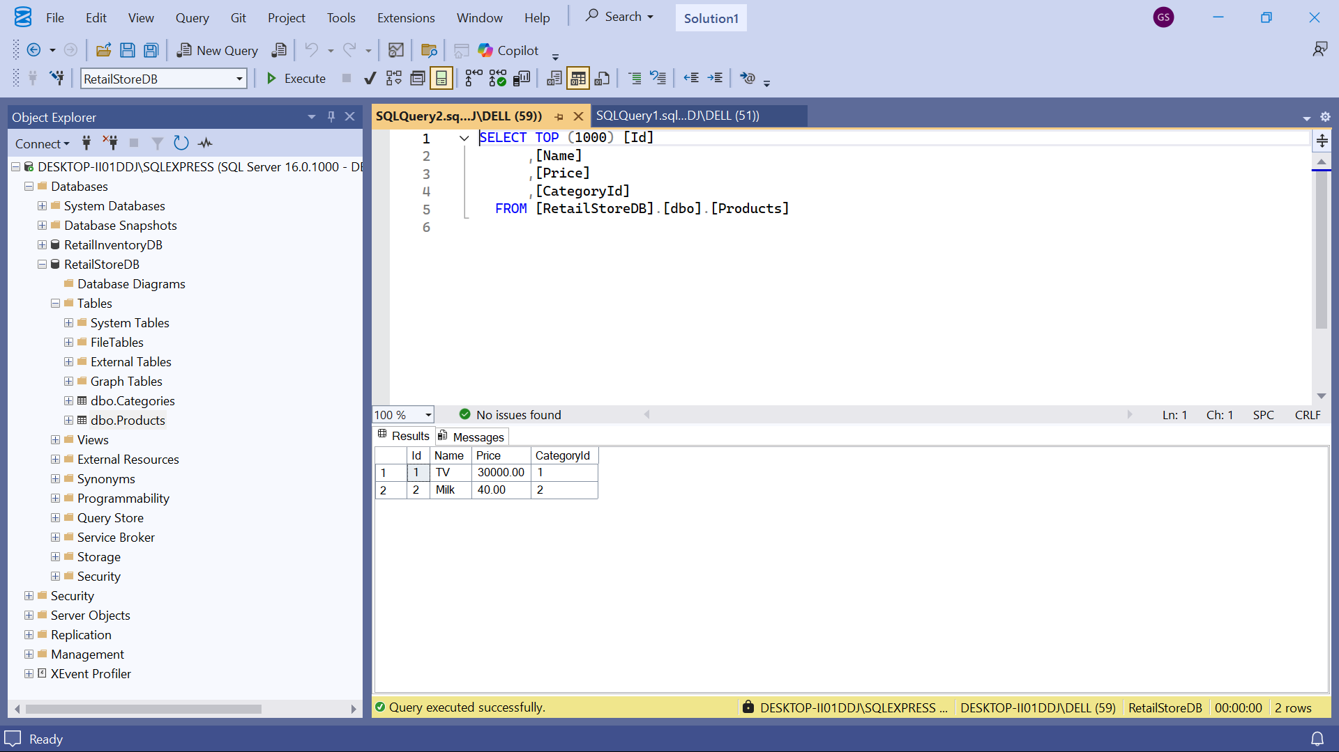

Program – 5:

Lab 5: Retrieving Data from the Database

Scenario:

The store wants to display product details on the dashboard.

Objective:

Use Find, FirstOrDefault, and ToListAsync to retrieve data.

Steps:

1. Retrieve All Products:

var products = await context.Products.ToListAsync();

foreach (var p in products)

Console.WriteLine($"{p.Name} - ₹{p.Price}");

2. Find by ID:

var product = await context.Products.FindAsync(1);

Console.WriteLine($"Found: {product?.Name}");

3. FirstOrDefault with Condition:

var expensive = await context.Products.FirstOrDefaultAsync(p => p.Price > 5000

0);

Console.WriteLine($"Expensive: {expensive?.Name}");

Sol:

Program.cs

using RetailApp;

using RetailApp.Models;

using Microsoft.EntityFrameworkCore;

var context = new AppDbContext();

// 1. Retrieve All Products

var products = await context.Products.ToListAsync();

Console.WriteLine("📦 All Products:");

foreach (var p in products)

Console.WriteLine($"{p.Name} - ₹{p.Price}");

Console.WriteLine();

// 2. Find by ID

var product = await context.Products.FindAsync(1);

Console.WriteLine($"🔍 Found by ID: {product?.Name}");

// 3. FirstOrDefault with Condition

var expensive = await context.Products.FirstOrDefaultAsync(p => p.Price > 50000);

Console.WriteLine($"💰 Expensive Product: {expensive?.Name}");

